Automated Assignment Group Deactivation Impact Assessment & Dependency Analyzer

Team & Problem Context

Team Information
Field | Details
Team Name | The Assist Alliance
College/Institution | KSRM College of Engineering
Number of Members | 5
Team Members | V. Mahamadh Basha (Team Lead), K. Gowthami, G. Gowthami, S. Venkata Kalyan, G. Thanusha.
Name of the problem statement chosen | Automated Assignment Group Deactivation Impact Assessment & Dependency Analyzer

Problem Statement
Assignment Groups are retired, merged or decommissioned during application sunsets, organisation restructuring, vendor transitions and support-model changes. Before that happens, administrators must manually check incidents, changes, CMDB records, business applications, service mappings, catalog items, assignment rules, notifications, workflows and custom apps. The process is slow, error-prone and easy to get wrong, because one missed reference is enough to cause an outage.

A Friday afternoon story. A support-model change is approved. An admin deactivates the "Database Support" group. It takes one click, and nothing warns them about what is still attached to it. Open incidents and changes are still assigned to the group. Assignment rules still route new tickets to it. Flows and notifications still point at it. CMDB items and business services still list it as their support group. The damage is quiet at first, and it surfaces on Monday morning as delayed tickets, silent automations and unowned services.
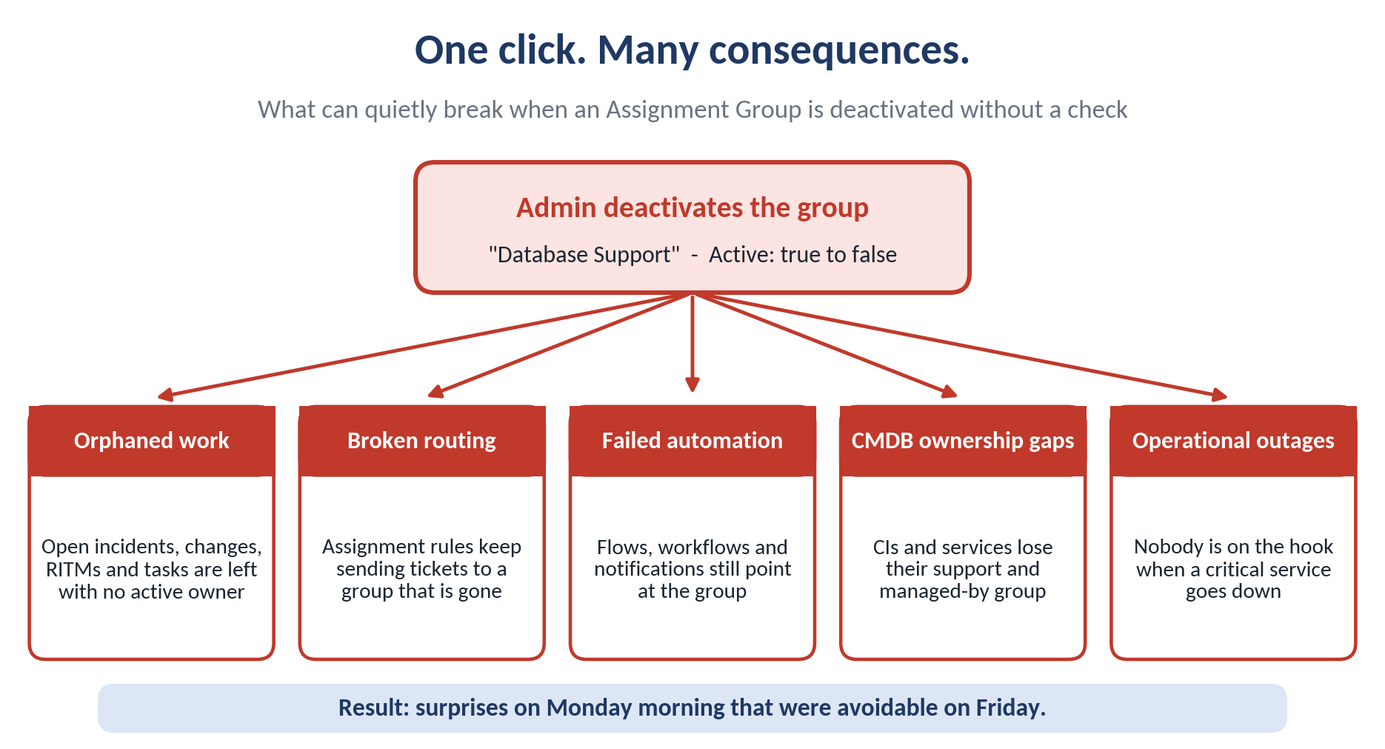
Figure 1. Operational risks triggered by unassessed Assignment Group deactivation.

Why it matters, and who feels it
Stakeholder | What they face today
ServiceNow administrators | Hours of searching across tables, with constant worry about what was missed.
ITSM managers | Orphaned tickets, missed SLAs and unclear accountability after a group disappears.
Service desk agents and end users | Requests routed to the wrong place, or to nobody at all.
CMDB owners | Configuration items and services left without a responsible group.
IT operations | Outages where no accountable team is on the hook.

Reasons blind deactivation is risky
Pain point | In plain words
1. Manual dependency checks | Admins must open many tables and screens by hand before every deactivation.
2. Operational dependencies | Incidents, problems, changes, RITMs, catalog tasks and memberships may still be tied to the group.
3. Hidden configuration links | Assignment rules, business rules, scripts, notifications, flows and workflows can reference the group without anyone remembering.
4. CMDB and service impact | CIs, business applications, business services and service mapping can lose their owner.
5. No risk-based guidance | There is no central view, no risk score and no remediation advice, so groups are deactivated too early.

2.Solution Innovation

2.1. My Approach
Our approach is to develop an intelligent, centralized Assignment Group Deactivation Impact Analyzer that identifies dependencies, evaluates potential risks, and supports safe deactivation through a structured assessment process.
The proposed solution consists of four specialized scanners, five core data tables, an incremental scanning mechanism, and independent AI agents working together to provide a comprehensive impact assessment.
- Four specialized scanners: Separate scanners examine ITSM records, configuration components, automation workflows, and CMDB and service relationships to discover dependencies associated with the selected Assignment Group.
- Centralized five-table data layer: Discovered dependencies and assessment information are maintained in five core tables, providing a persistent source of information for subsequent searches, analysis, and reporting.
- Incremental scanning mechanism: Rather than repeating a complete scan for every search, the system checks stored scan information and record update timestamps. Unchanged records can reuse existing results, while new or modified records are selected for reassessment.
- Independent AI agents: Dedicated agents analyze discovered dependencies, assess potential impact and risk, and provide actionable remediation recommendations according to their assigned responsibilities.
- Manager-facing assessment dashboard: When a manager searches for an Assignment Group, the system retrieves the relevant stored dependency information, evaluates data freshness, and presents the dependency summary, risk level, unresolved issues, and recommended actions.
- Controlled deactivation process: After the identified dependencies are addressed, the system revalidates the assessment and follows the required approval process before allowing deactivation.
The overall objective is to replace fragmented, repetitive manual checks with a centralized, reusable, and risk-aware assessment process that improves dependency visibility, reduces unnecessary rescanning, and supports safer Assignment Group deactivation.

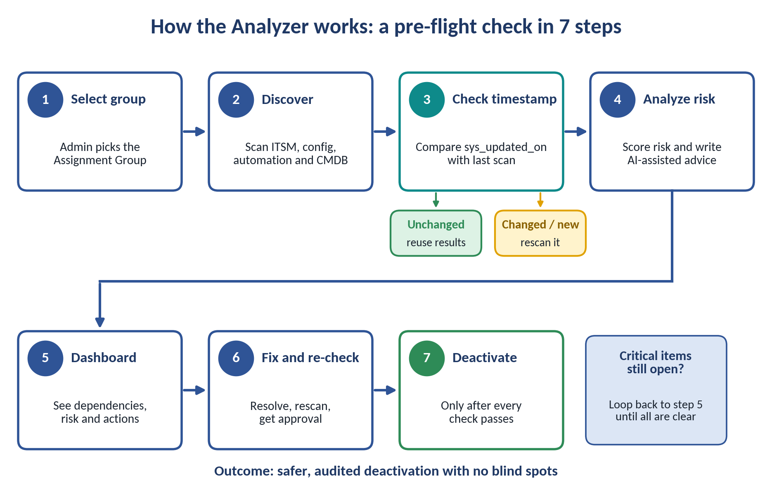

Figure 2. Seven-stage workflow for dependency discovery, risk assessment, remediation, and controlled deactivation.

What the admin sees at the end: a clear verdict instead of a guess.
Group | Database Support
Verdict | RISK: HIGH. NOT READY FOR DEACTIVATION.
Found | 69 dependencies, 64 unresolved: 52 incidents, 8 change requests, 3 group memberships, 2 business services, 2 Flow Designer references, 1 business application, 1 assignment rule
Sample records | INC0010015, CHG0000077, SNSVC00004659
Recommended actions | Reassign active records; review assignment rules and remove memberships; update CMDB ownership; re-run the assessment

Innovation & Differentiation
What is different | Why it stands out
Multi-layer discovery | Looks beyond open incidents: assignment rules, scripts, Flow Designer, workflows, custom apps and CMDB relationships are all checked.
Incremental scanning | Rescans only what changed since the last assessment, so repeat checks are fast instead of starting from zero.
Central dependency registry | One place for dependencies, timestamps, risk levels and remediation status, which makes tracking and audits simple.
Four specialized scanners | Examines ITSM records, configuration components, automation workflows, and CMDB and service relationships to identify dependencies across multiple platform areas.
Five-table centralized data layer | Stores dependency findings and assessment information in five core tables, allowing the dashboard to retrieve existing results without repeating the entire discovery process.
AI-Assisted Impact Analysis | Separates impact analysis, risk assessment, and remediation recommendations into dedicated agent responsibilities, making the design modular and extensible.
Independent AI-agent analysis | Script Includes and Glide Record hold the scanning logic, and Flow Designer coordinates assessment and approvals, so new scanners plug in easily.
Risk-based readiness assessment | Classifies potential risks and highlights unresolved dependencies that must be addressed before deactivation.
Remediation and revalidation | Tracks corrective actions, rechecks dependencies, and supports approval-based deactivation rather than relying on manual follow-up.
Reusable, scalable architecture | Separates scanners, data storage, analysis, and workflow orchestration so additional dependency sources and capabilities can be introduced as needed.

Why This Matters

- Prevents operational failures: Identifies supported operational and configuration dependencies before an Assignment Group is deactivated.
- Reduces unnecessary work: Reuses stored results for unchanged records and refreshes data when needed.
- Improves decision-making: Presents dependency counts, risk assessments, unresolved issues, and recommended actions in one dashboard.
- Supports safer deactivation: Combines remediation, revalidation, and approval checks before the final action.
- Improves governance: Centralizes assessment information and supports tracking, reporting, and audit history.

System Architecture:

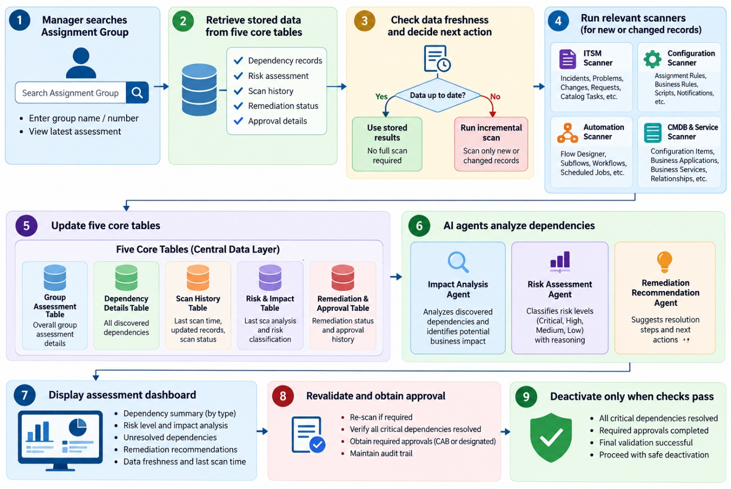

Figure 3. Layered architecture connecting dependency scanners, incremental analysis, risk evaluation, and approval controls.

Implementation & Feasibility

Technical Stack
Component | Technology / Module
Front-end and back-end elements | ServiceNow UI Builder / Workspace, JavaScript, server-side Script Includes, GlideRecord APIs
ServiceNow modules | ITSM, CMDB, Service Catalog, Flow Designer
ServiceNow features | Business Rules, sys_dictionary, Scheduled Jobs, Reports & Dashboards, Approval Workflows
High level design | Dependency scanners, incremental scanning engine, dependency registry, AI-assisted risk analysis, remediation and revalidation
Supporting tools / languages | ServiceNow Studio, JavaScript, ServiceNow tables and APIs, AI capabilities (where available)

The architecture below shows how an admin starts an assessment, how records are discovered, how unchanged records are skipped, how AI analyses the findings and how the system validates a safe deactivation.

Project Timeline
We break the work into 9 phases over about 3 weeks, overlapping where practical. Each phase ends with something we can demo.
Phase | Implementation activity | Suggested week | Milestone
1 | UI & Assessment Setup | Week 1 | Group selection and assessment dashboard
2 | ITSM Record Scanner | Weeks 1-2 | Incidents, problems, changes, RITMs, catalog tasks, group memberships
3 | Configuration Scanner | Week 2 | Assignment rules, business rules, scripts, UI Actions, notifications
4 | Automation Scanner | Week 2 | Flow Designer flows, subflows, legacy workflows, scheduled jobs
5 | CMDB & Service Scanner | Weeks 2-3 | CIs, business applications, business services, application services, relationships
6 | Custom Table & Metadata Scanner | Week 3 | Custom tables, reference fields, cross-application dependencies
7 | Incremental Scanning Engine | Weeks 2-3 | Timestamp comparison, scan queue, dependency registry
8 | AI Risk Analysis & Remediation | Week 3 | Risk classification, recommendations, remediation tracking
9 | Integration, Testing & Final Demo | Week 3 | Revalidation, approval workflow, reports, end-to-end testing

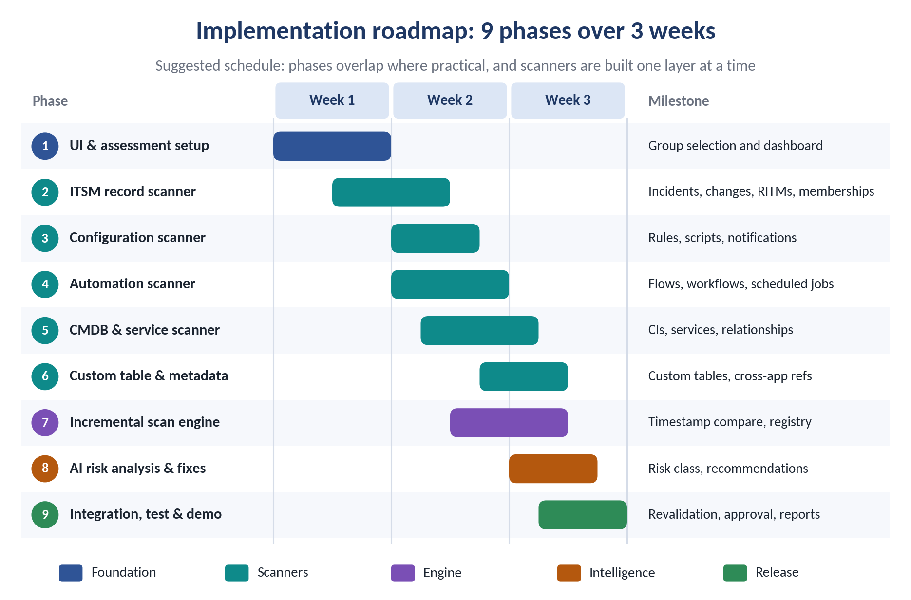

Figure 4. Three-week implementation roadmap with phased deliverables and integration milestones.

Feasibility Assessment
Feasibility | Realistic as a hackathon MVP with a focused set of scanners.
Resources | A ServiceNow development instance and team skills in the platform, JavaScript, GlideRecord and Flow Designer.
MVP priority | ITSM scanner, configuration scanner, timestamp-based incremental scanning, risk dashboard and remediation workflow.
Main risks | Complex scripted dependencies, Flow Designer internals, CMDB relationship traversal and scan performance.
Mitigation | Start with core ITSM references and assignment rules, then add the other scanners one at a time.
Dependency | AI features depend on the availability and permissions of ServiceNow AI capabilities. The scanners and dashboard work without them.

Impact & Metrics

Measurable Outcomes
KPI | Success measurement
Dependency detection coverage | Number and percentage of dependencies identified across the four scanner categories.
Assessment time reduction | Time required for an assessment compared with the existing manual process.
Incremental scan efficiency | Reduction in records rescanned by reusing stored results for unchanged records.
AI Risk Assessment Quality | Accuracy of risk classifications compared with validated test cases and expected outcomes.
Remediation effectiveness | Percentage of identified dependencies resolved and successfully revalidated.
Data Freshness | Percentage of assessments using current dependency data or successfully refreshed results.
Safe Deactivation Readiness | Percentage of deactivation assessments that satisfy required dependency checks and approval conditions
Auditability | Percentage of assessments with recorded findings, scan history, remediation status, and approval history.
Note: Exact targets will be set after baseline testing against a manual assessment, so every number we claim can be backed up.

Real-World Applicability
One dashboard for the whole picture. A manager enters an Assignment Group name or Sys ID and sees the complete impact on a single screen:
- Group overview: name, status, manager and last scan time.
- Dependency summary: total, active and unresolved dependencies.
- Risk assessment: Low, Medium or High, with an overall deactivation readiness status.
- Dependency breakdown: incidents, changes, requests, assignment rules, automation, custom tables and CMDB relationships.
- Incremental scan status: records reused versus newly scanned or updated.
- AI recommendations: impact summary, remediation suggestions and next steps.
- Remediation and approval: resolution tracking, revalidation results and approval status.
- Executive report: consolidated findings for management review.
Path to production. The solution grows by adding scanners, supporting custom applications, scheduling incremental scans, and adding role-based access, audit history and approval workflows.
Who benefits: ServiceNow administrators, ITSM managers, CMDB owners, platform architects and IT operations teams responsible for Assignment Group consolidation, retirement and governance.
Manager Dashboard:
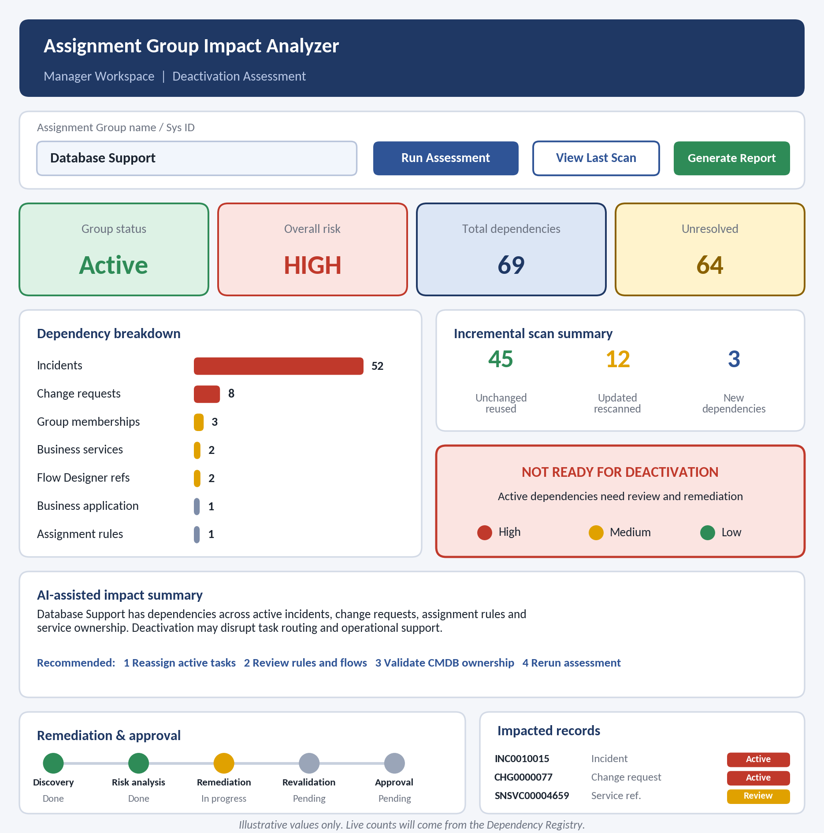
Figure 5. Proposed administrator dashboard showing dependency counts, risk level, unresolved items, and remediation status.

Team Roles & Expertise

Role Assignment
Name | Role | Team Lead | Key responsibilities
V. Mahamadh Basha | Team Lead & Solution Architect | Yes | Overall coordination, system architecture, dependency registry, integration
K. Gowthami | Workflow & Automation Developer | No | Flow Designer, assessment workflows, approvals, remediation automation
G. Gowthami | AI & Impact Analysis Developer | No | AI-assisted impact summaries, risk classification, recommendations
S. Venkata Kalyan | Scanner & Backend Developer | No | ITSM, configuration, automation and CMDB scanners; incremental scanning
G. Thanusha | UI, Dashboard & QA Developer | No | Manager dashboard, dependency reports, testing, validation, bug fixing

Leadership and Coordination
- Team Leader: V. Mahamadh Basha oversees planning, technical decisions, task allocation and milestone completion.
- Skill Mapping: tasks follow each member's strength in ServiceNow development, automation, AI, backend scanning and UI design.
- Collaboration: regular team discussions keep scanner development, workflow integration and dashboard work in step.
- Progress Tracking: completed tasks and blockers are reviewed so each phase meets its objective.
- Integration and Quality: joint testing covers dependency detection, incremental scanning, risk assessment and safe deactivation.

Diagrams & Visual Aids

Visual Aid 1: Manual vs. Automated Dependency Assessment

Purpose: show the innovation and the efficiency gain side by side

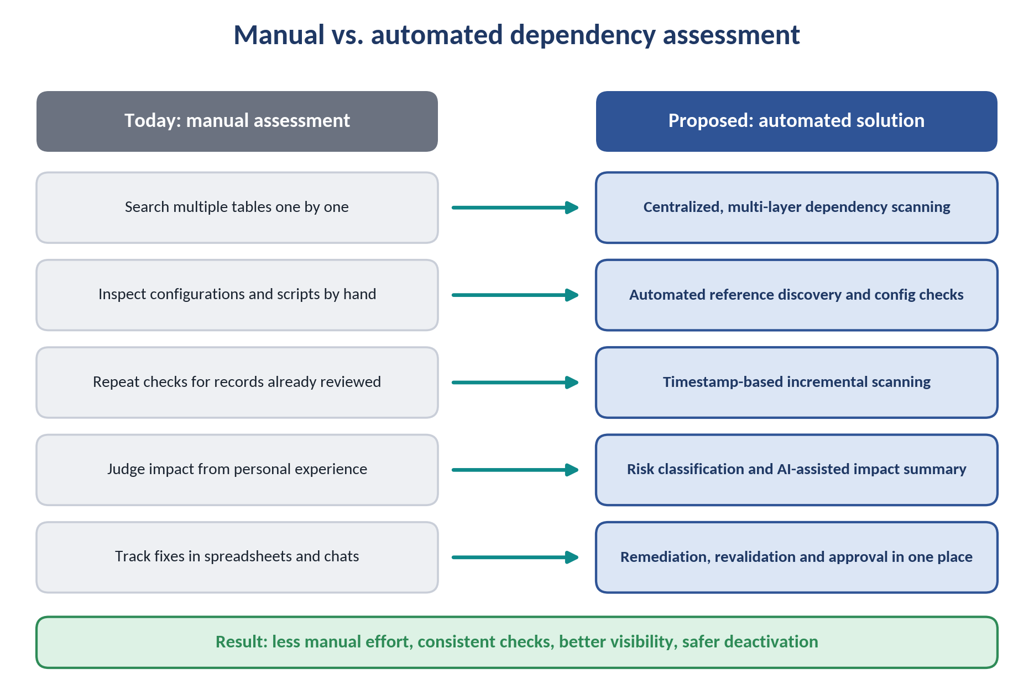

Figure 6. Comparison of manual dependency verification with the proposed automated assessment process.

Expected outcome: less manual effort, more consistent checks, better visibility and safer deactivation. Manual reviews can miss references buried in automation and scripted configuration, which is exactly where broader analysis pays off.

Visual Aid 2: Dependency Mapping & Risk Visualization
Purpose: show how one Assignment Group connects to four areas of the platform: ITSM operations, configuration, automation, and CMDB and services. Each dependency carries its source, type, status and risk level (red for High, amber for Medium, green for Low).
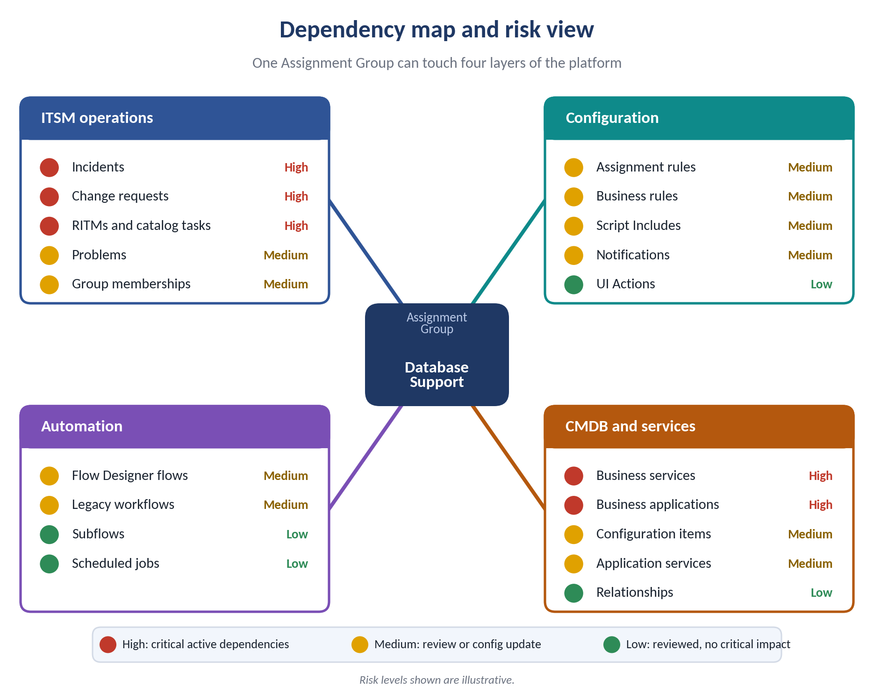

Figure 7. Dependency map highlighting operational, configuration, automation, and CMDB risks associated with a selected group.

Expected outcome: a visual map that shows what deactivation would affect and helps admins prioritise remediation before they proceed.

References
- ServiceNow GlideRecord API: querying and retrieving records. https://www.servicenow.com/docs/r/xanadu/api-reference/server-api-reference/c_GlideRecordAPI.html
- ServiceNow Script Includes: reusable server-side logic and scanning code. https://www.servicenow.com/docs/r/api-reference/scripts/c_ScriptIncludes.html
- ServiceNow Flow Designer: assessment workflows, remediation steps and approvals. https://www.servicenow.com/docs/r/application-development/flow-designer.html
- ServiceNow System Dictionary: table structures, fields and metadata. https://www.servicenow.com/docs/r/platform-administration/table-administration-and-data-management/c_SystemDictionary.html
- ServiceNow Common Service Data Model (CSDM): CMDB structure and service relationships. https://www.servicenow.com/docs/r/servicenow-platform/common-service-data-model-csdm/csdm-landing-page.html
- ServiceNow Scheduled Jobs: periodic and incremental assessments. https://www.servicenow.com/docs/r/platform-administration/time-configuration/c_ScheduledJobs.html
- ServiceNow Developer Site: learning resources and examples. https://developer.servicenow.com/
- ServiceNow Documentation. https://docs.servicenow.com

